**Experiment 7.1**

**Student Name:** Sahil Kaundal **UID:** 21BCS8197

**Branch:** BE CSE (Lateral Entry) **Section/Group:** 616/A

**Semester:** 6th **Date of Performance:** 25/04/2023

**Subject Name:** CC-2 Lab **Subject Code:** 20CSP-351

1. **Aim/Overview of the practical:**

1-bit and 2-bit Characters

We have two special characters:

* The first character can be represented by one bit 0.
* The second character can be represented by two bits (10 or 11).

Given a binary array bits that ends with 0, return true if the last character must be a one-bit character.

<https://leetcode.com/problems/1-bit-and-2-bit-characters/>

1. **Apparatus / Simulator Used:**

* Windows 7 or above
* Google Chrome

1. **Objective:**

* To understand the concept of Divide and Conquer.

A divide-and-conquer algorithm recursively breaks down a problem into two or more sub-problems of the same or related type, until these become simple enough to be solved directly. The solutions to the sub-problems are then combined to give a solution to the original problem.

1. **Code:**

class Solution {

    public boolean isOneBitCharacter(int[] bits) {

        if (bits == null || bits.length == 0) {

            return false;

        }

        int n = bits.length;

        if (n == 1) {

            return bits[0] == 0;

        }

        if (bits[n - 1] != 0) {

            return false;

        }

        boolean[] dp = new boolean[n];

        dp[0] = bits[0] == 0;

        dp[1] = bits[0] != 0 || bits[1] != 1;

        for (int i = 2; i < n - 1; i++) {

            if (bits[i] == 0) {

                dp[i] = dp[i - 2] || dp[i - 1];

            } else if (bits[i] == 1) {

                dp[i] = dp[i - 2] && bits[i - 1] == 1;

            }

        }

        return dp[n - 2];

    }

}

**4. Result/Output/Writing Summary:**

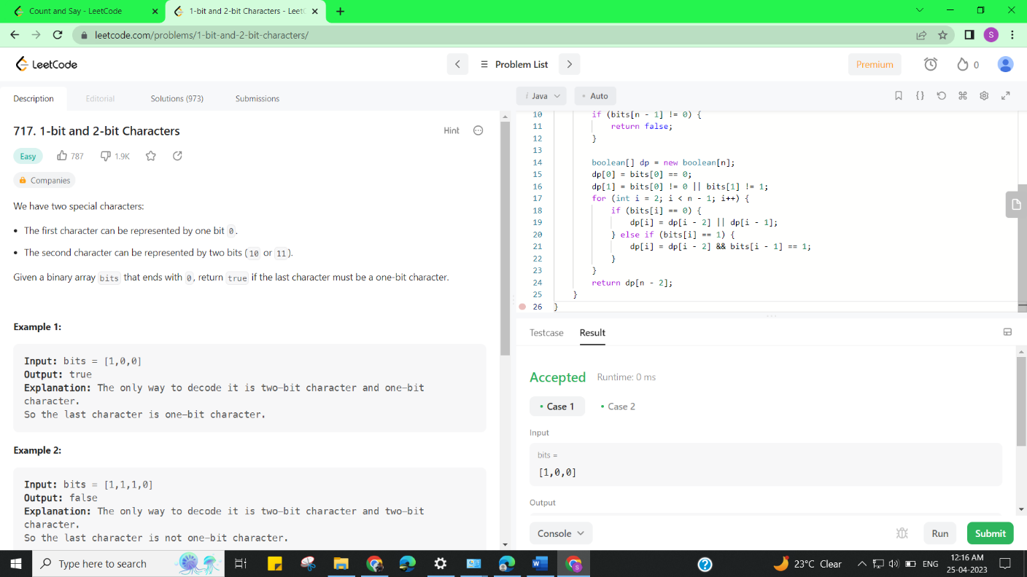

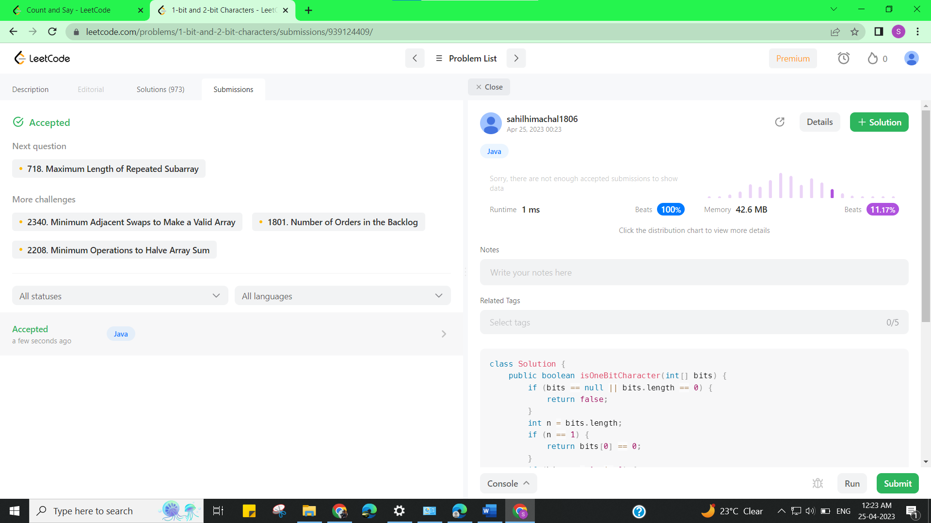

**Experiment 7.2**

1. **Aim/Overview of the practical:**

Count and Say

The **count-and-say** sequence is a sequence of digit strings defined by the recursive formula:

* countAndSay(1) = "1"
* countAndSay(n) is the way you would "say" the digit string from countAndSay(n-1), which is then converted into a different digit string.

<https://leetcode.com/problems/count-and-say/>

1. **Apparatus / Simulator Used:**

* Windows 7 or above
* Google Chrome

1. **Objective:**

* To understand the concept of Divide and Conquer.

A divide-and-conquer algorithm recursively breaks down a problem into two or more sub-problems of the same or related type, until these become simple enough to be solved directly. The solutions to the sub-problems are then combined to give a solution to the original problem.

1. **Code:**

#include<bits/stdc++.h>

using namespace std;

class Solution {

public:

    string countAndSay(int n) {

        if(n==1){

            return "1";

        }

        string prev=countAndSay(n-1);

        cout<<n<<" "<<prev<<"\n";

        string ans;

        int len=prev.length();

        for(int i=0;i<len;){

            int j=i;

            int count=0;

            while(prev[j]==prev[i]&&j<len){

                j++;

                count++;

            }

            char c='0'+count;

            ans+=c;

            ans+=prev[i];

            i=j;

        }

        return ans;

    }

};

1. **Result/Output/Writing Summary:**

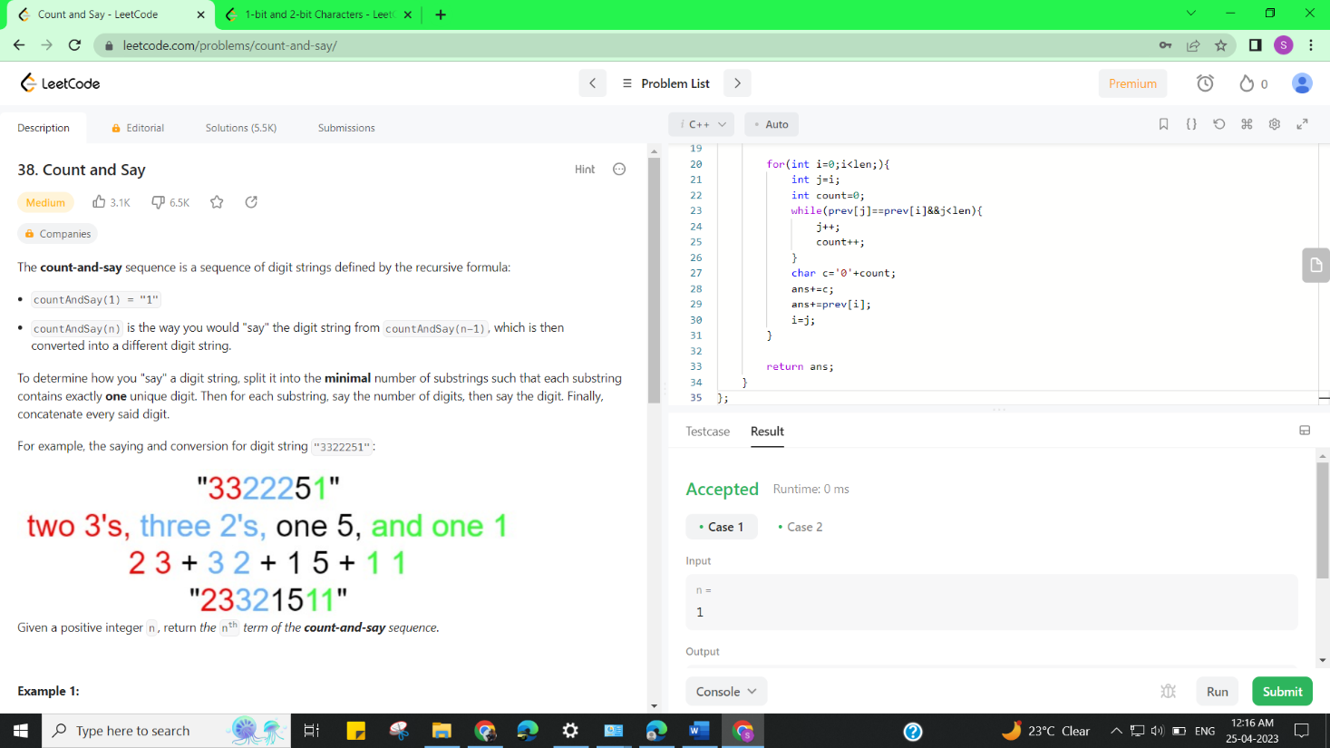

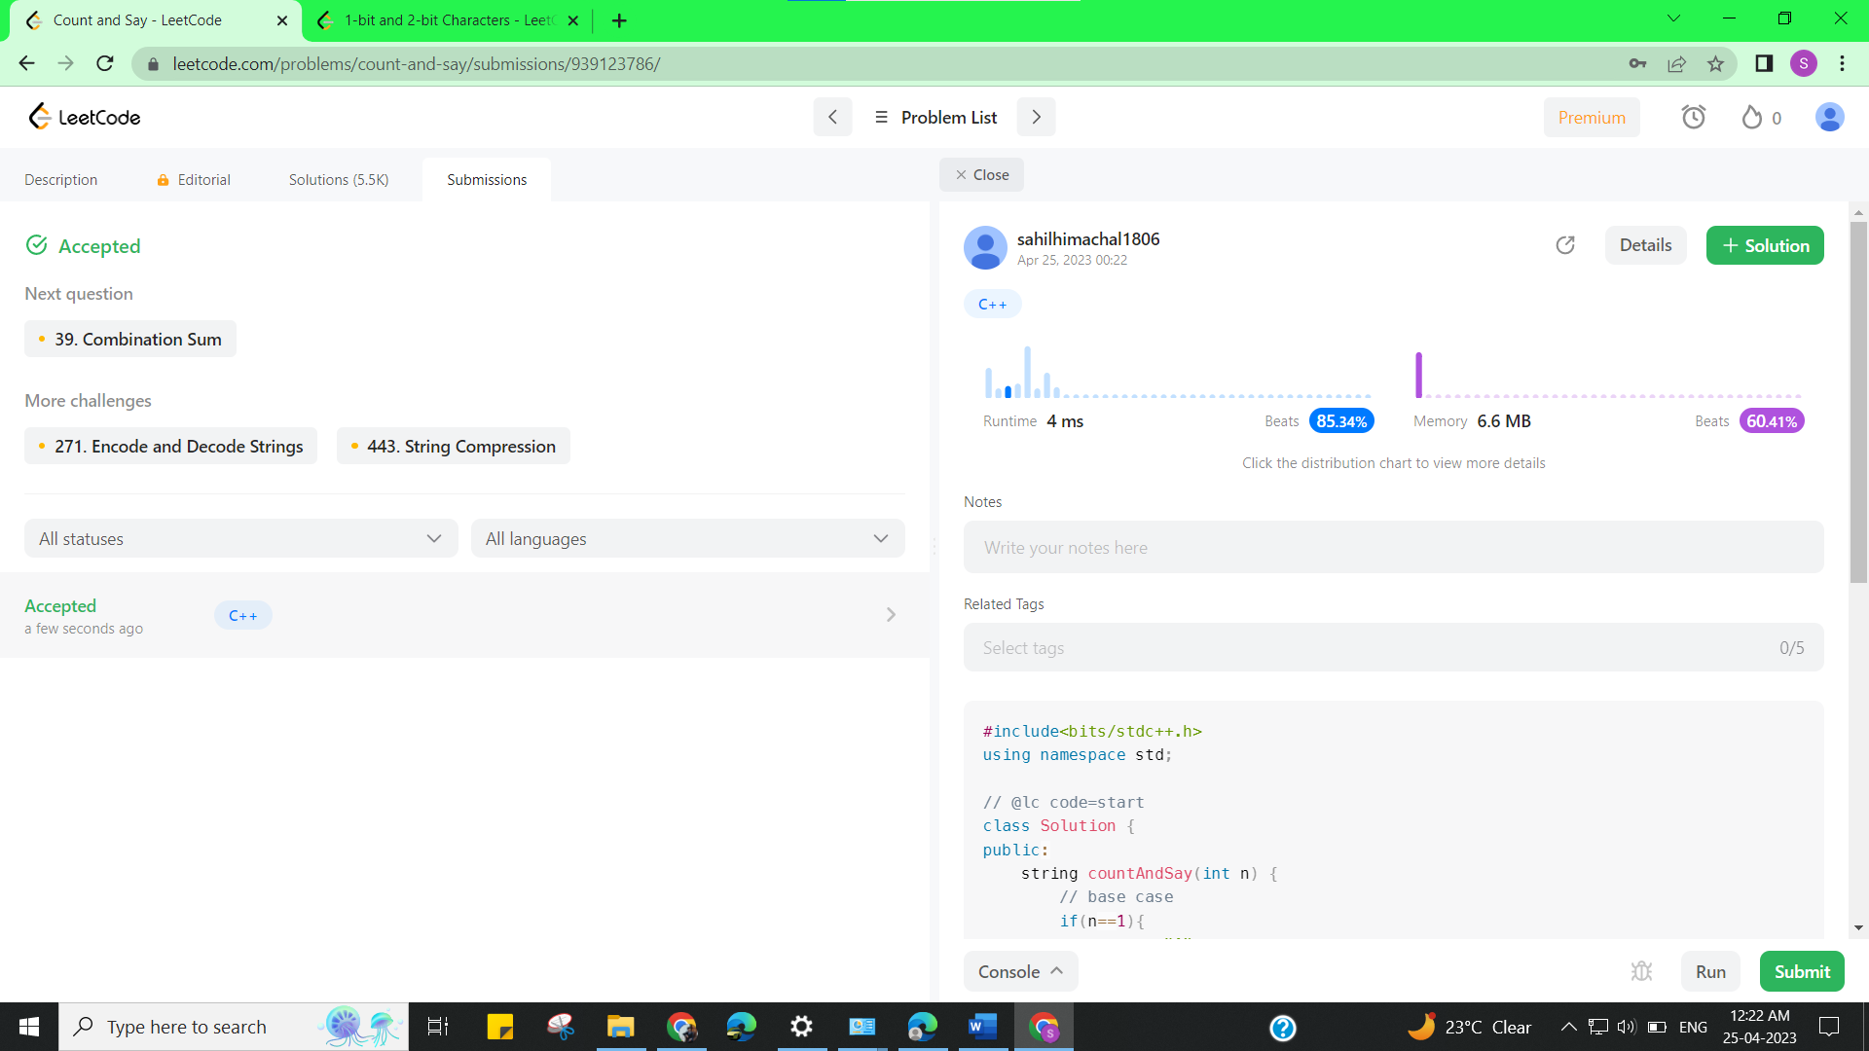

**Learning outcomes (What I have learnt):**

* Learned the concept of Divide and Conquer.